TIME SERIES WITH PROPHET

Prophet follows the sklearn model API. Here we create an instance of the Prophet class and then call its fit and predict methods.
The input to Prophet is always a dataframe with two columns: "ds" and "y". The ds (datestamp) column should be of a format expected by Pandas, ideally YYYY-MM-DD for a date or YYYY-MM-DD HH:MM:SS for a timestamp. The y column must be numeric, and represents the measurement we wish to forecast.

Visit: https://facebook.github.io/prophet/docs/quick_start.html#python-api

Model:

In this model, we will predict daily sales. We will not include November 2019, December 2019 and December 2022 because they do not have enough data. The first two months in the dataset have missing daily sales values. On the other hand, we do not have data for the second half of December 2022. Therefore, their daily sales will be misleading for our prediction. Also, by excluding December 2022, we will have an opportunity to compare forecasted sales with the actual values. So, in this model, we will use data beginnig from January 2020 until the end of Nvember 2022.

Since we have Subtotal values until 11 December 2022, we can check the success of our Prophet model by using these actual sales values.

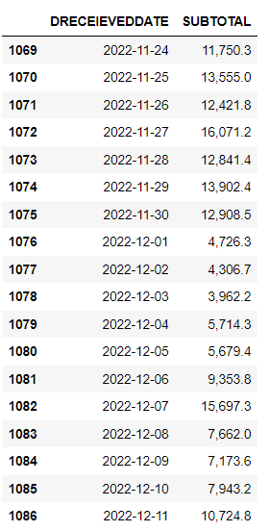
Sales (SUBTOTAL) in Original Data Forecast (yhat)
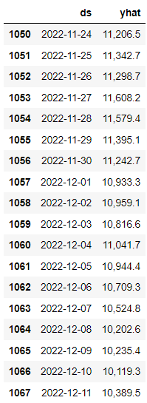

Let’s see the sales forecasting in June. The last 10 days in June as an example:
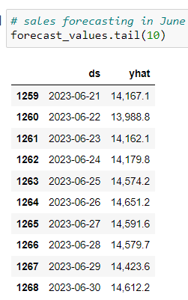

Forecasting of Daily Sales from December 2022 until the end of June 2023 in Graph:

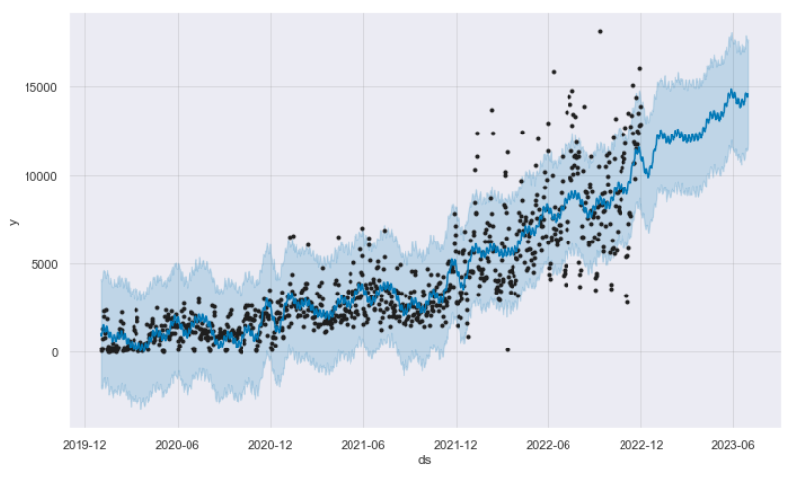
The plot above shows the predictions in the actual term (January 2020-December 2022) as weel as the following term beginning from December 2022 until the end of June (see the trend without values).

